**Day-3 (5th Dec 2022)**

**CLASS COMPONENT**

q1) Declare a class component “University”. The functionality of that particular class component is to print name and roll number. Export that class component to app.js and run the application.

index.js

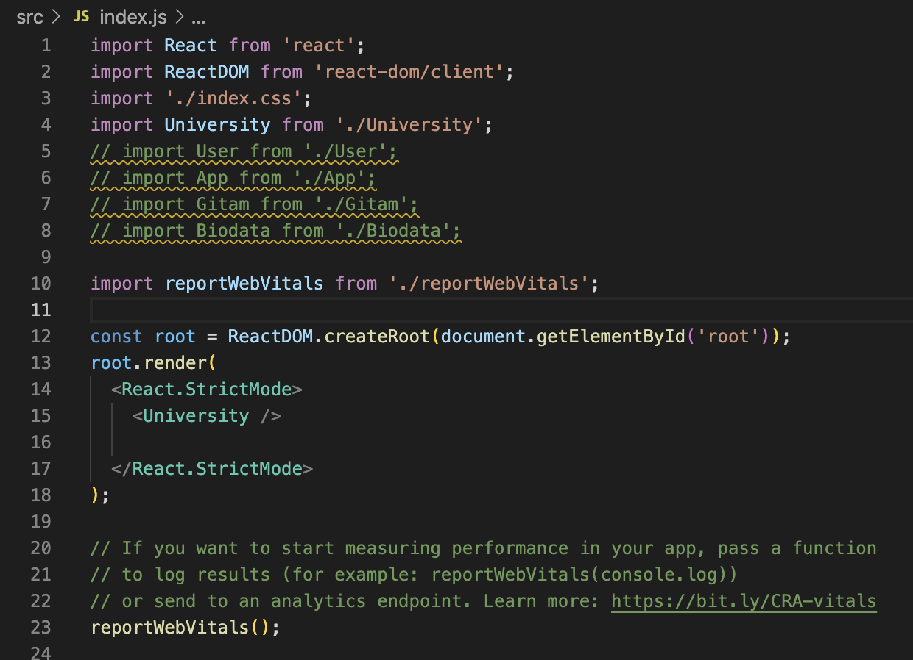

University.js

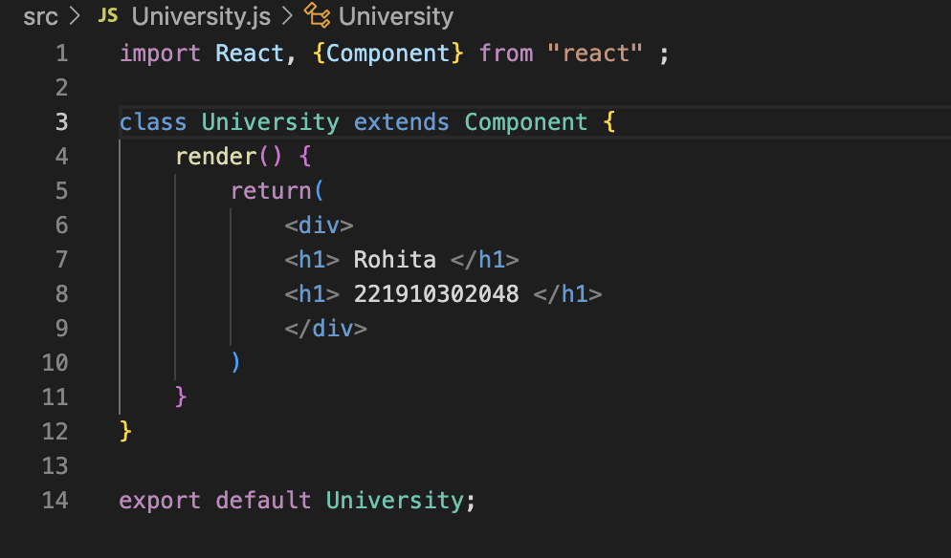

q2) 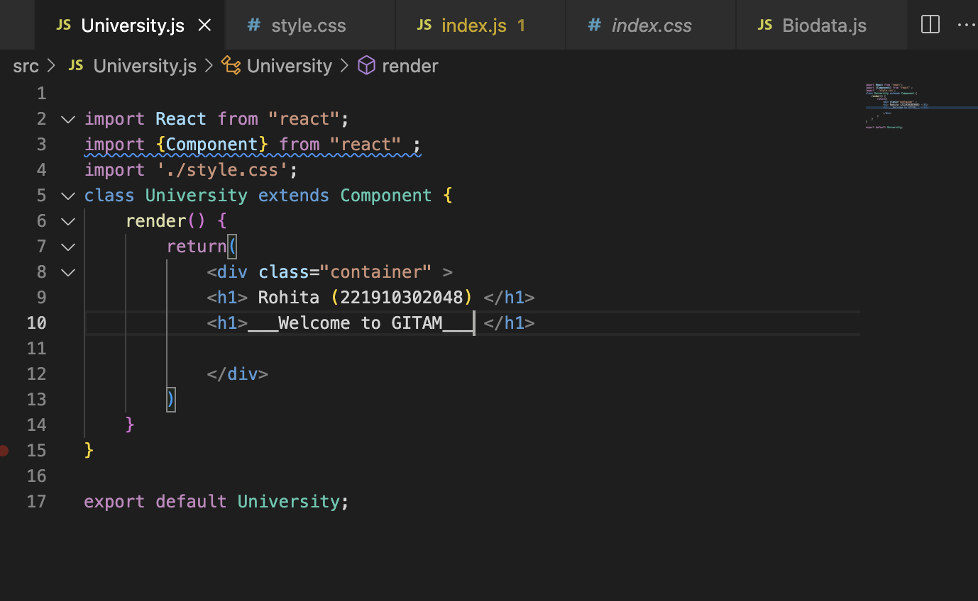

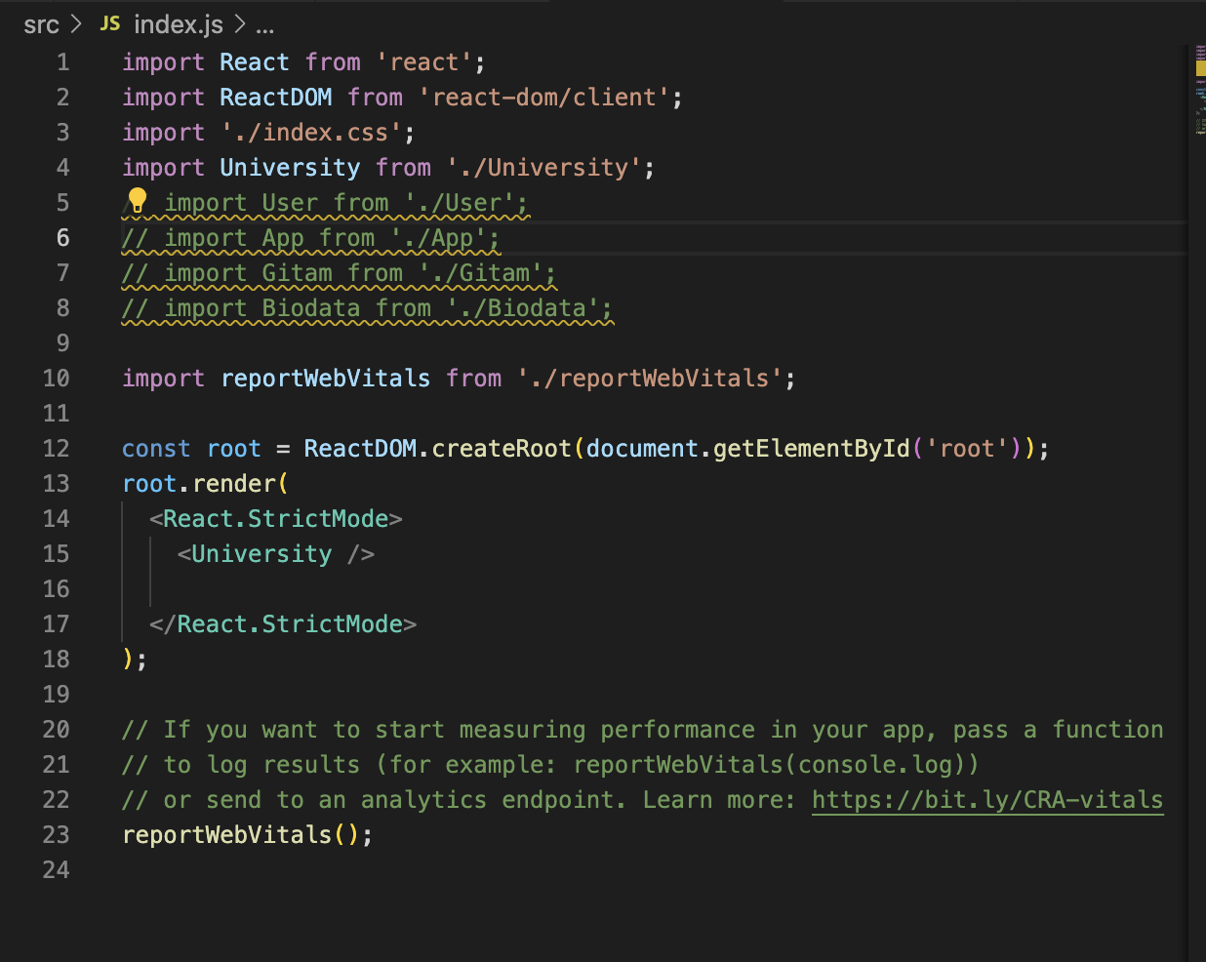

Output :

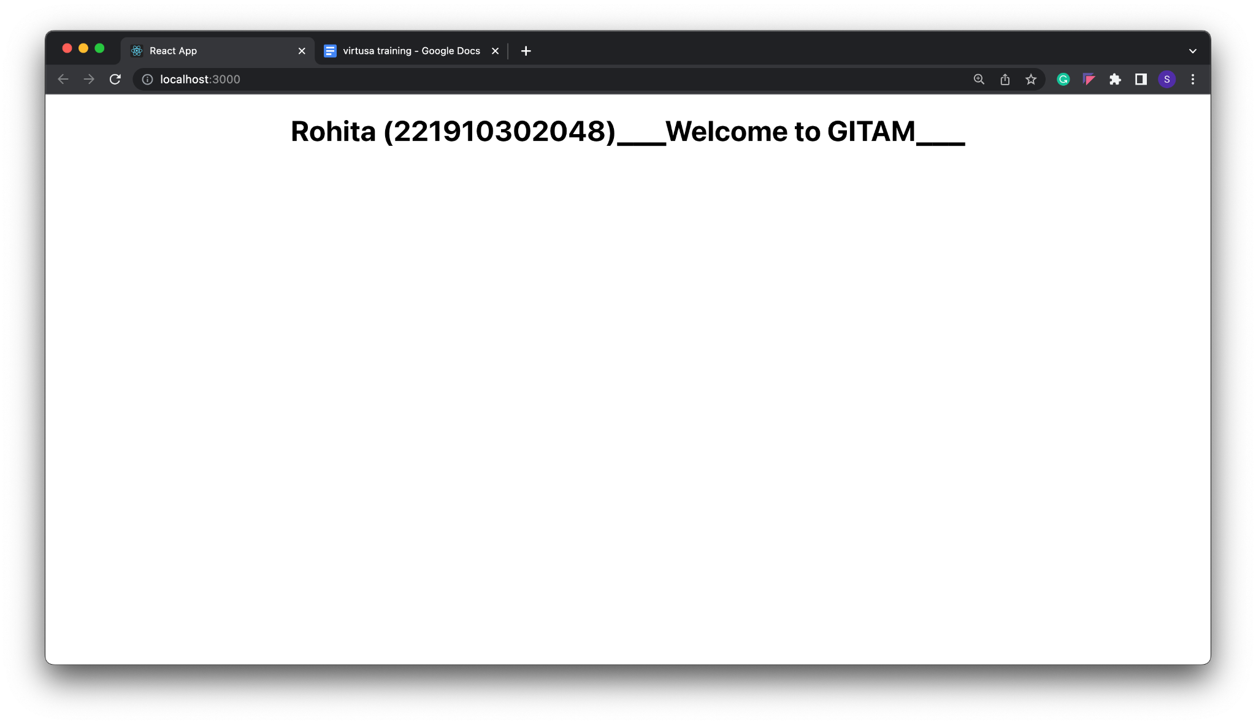

**USE OF BUTTON ( ON CLICK EVENT) / USAGE OF VARIABLE**

q3) 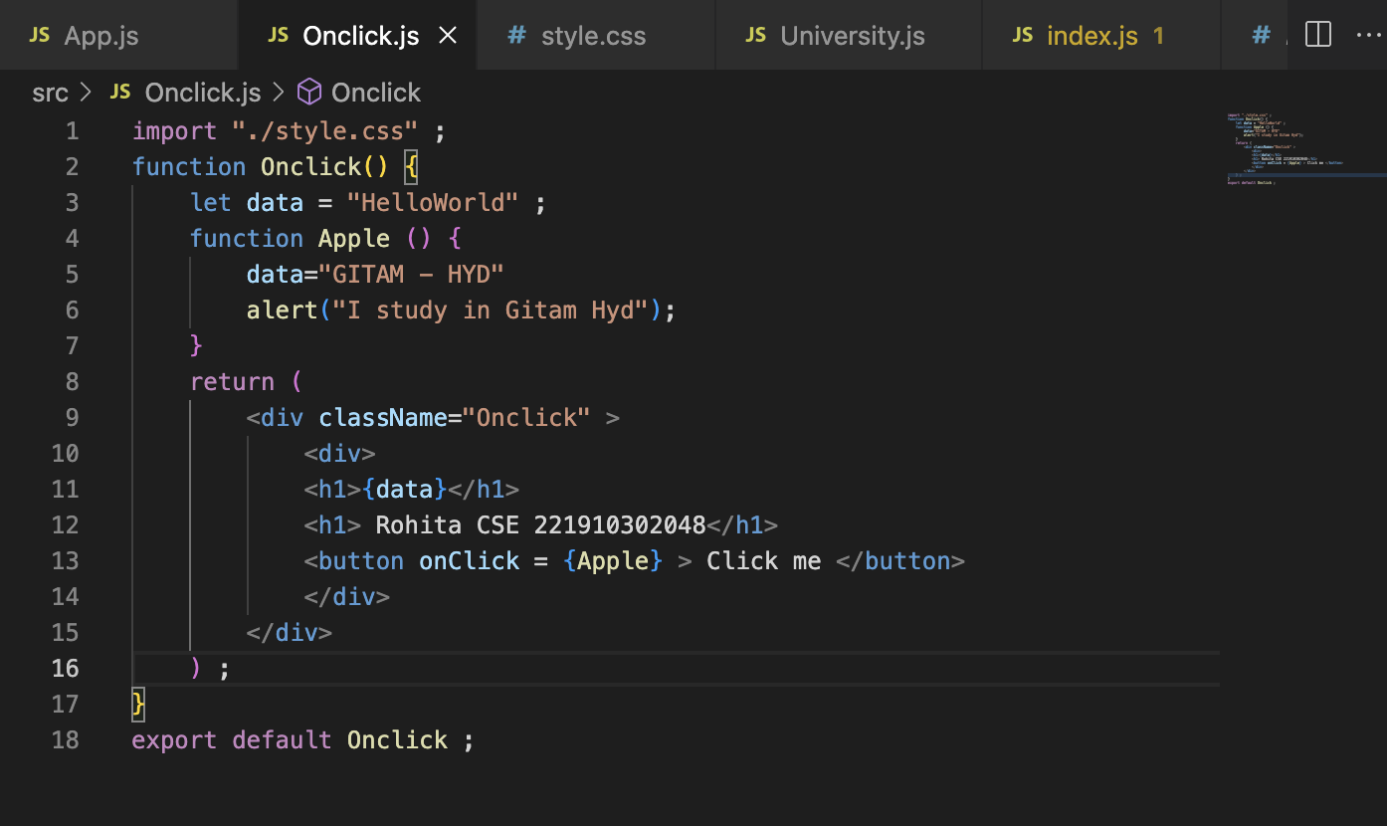

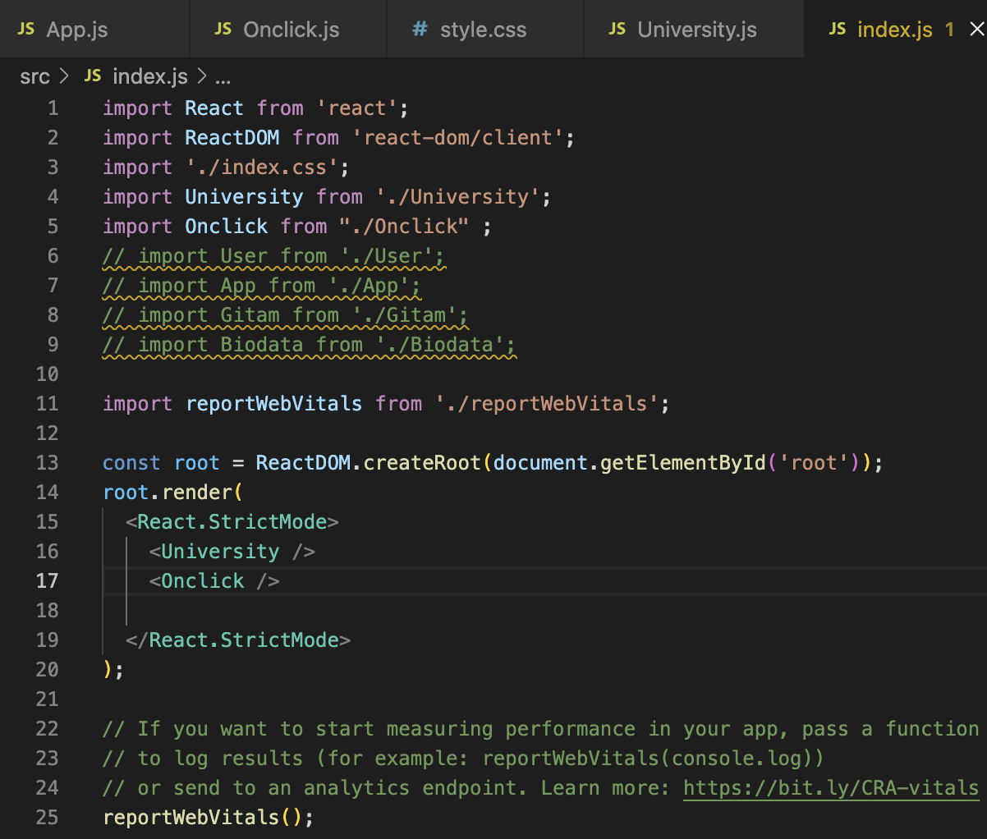

Output :

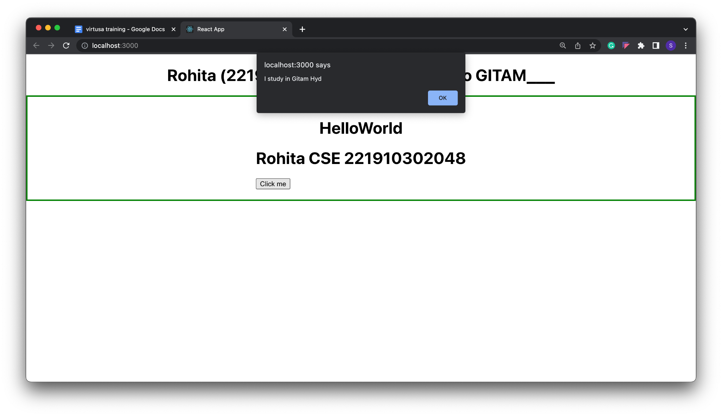

ASSIGNMENT-1

1. **Create a class component called "GITAM" ,that class Component needs to print "WELCOME TO GITAM". Export that class**

gitam.js

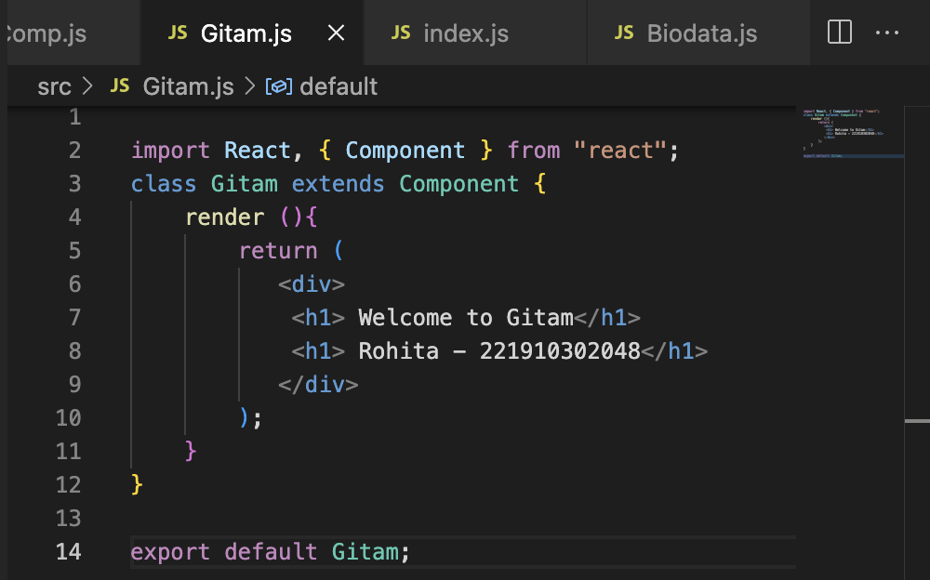

App.js

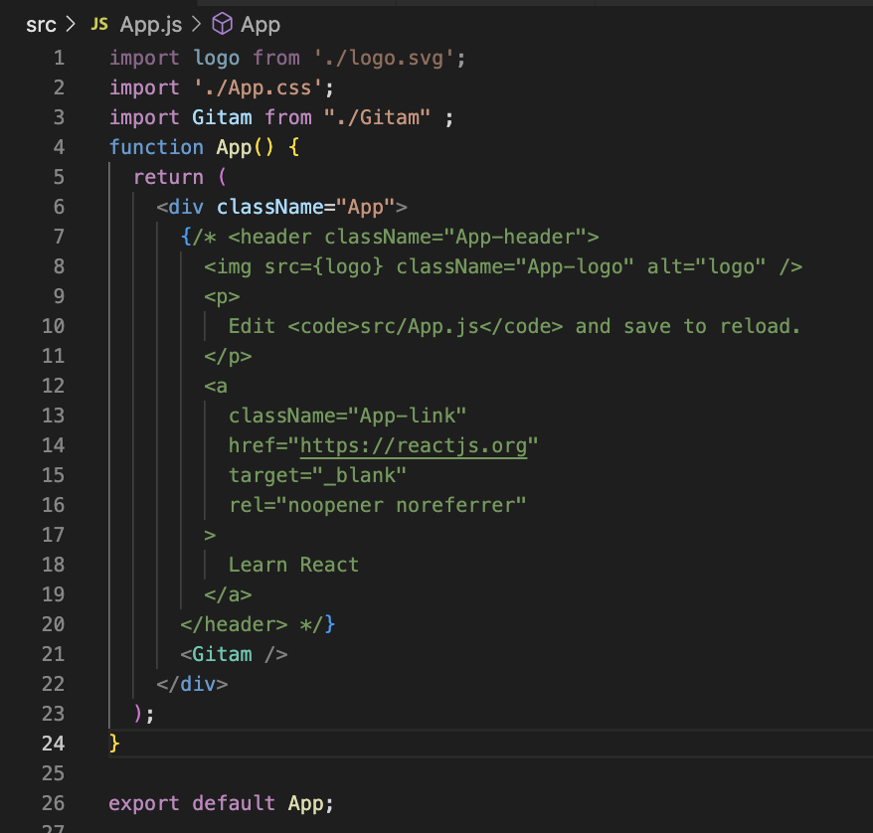

index.js

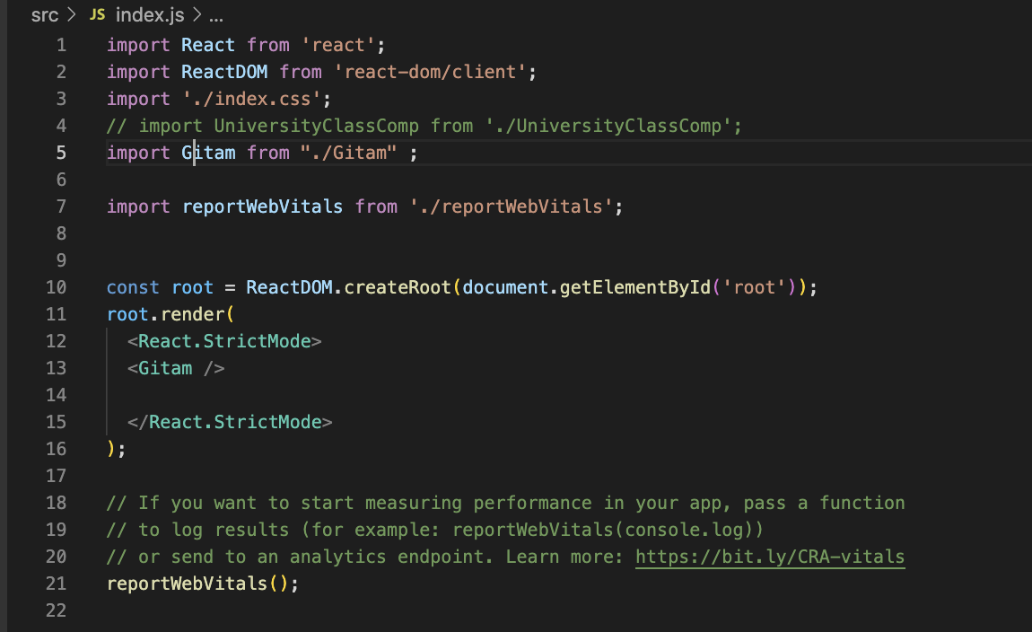

**Output :**

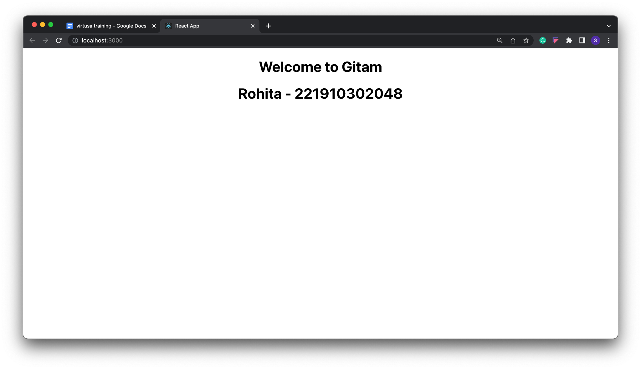

**2.In App.js , inside the App function, create one function called Banana and it need to return your name.**

**App.js**

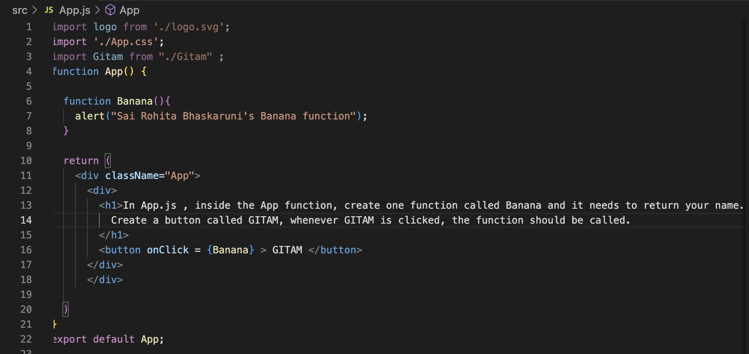

**Index.js**

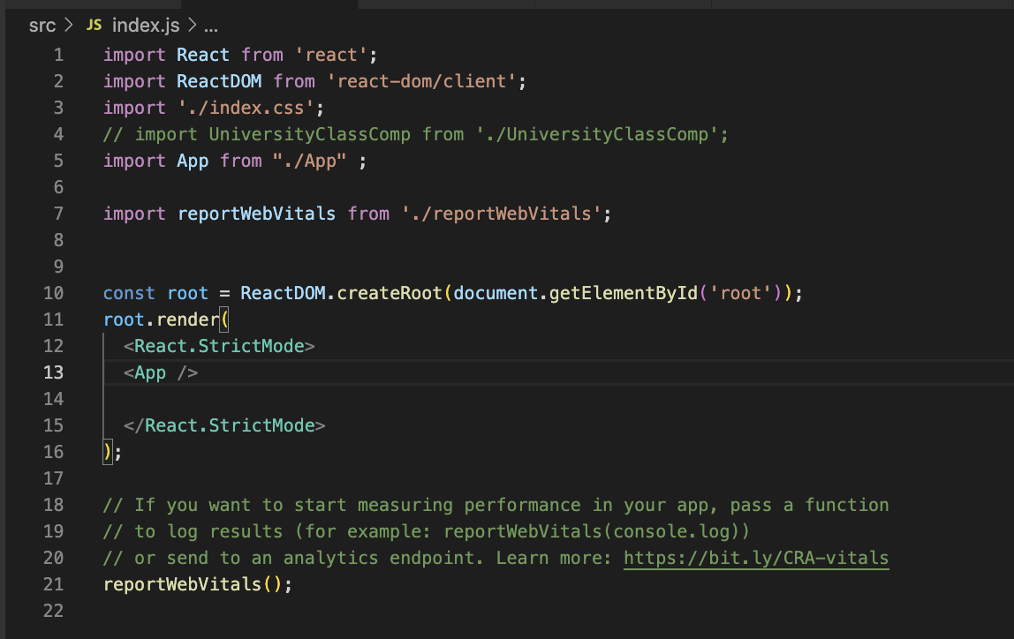

**Output :**

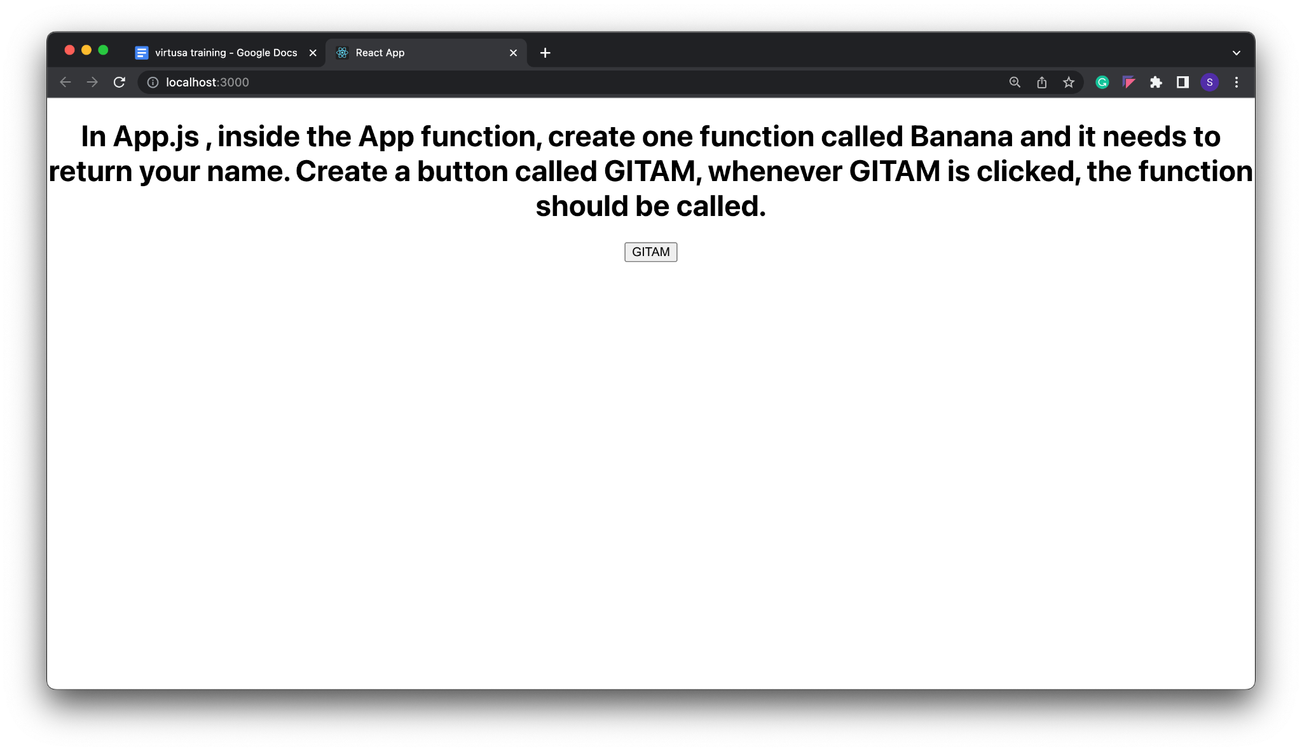

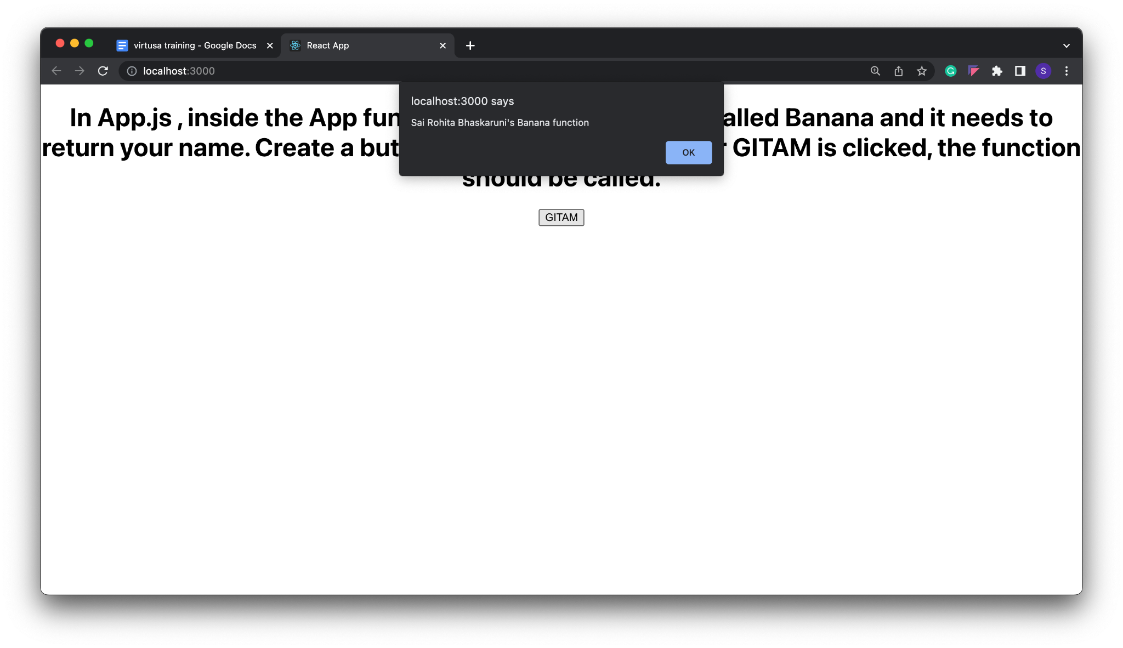

**3. In App.js, create a variable item, pass the value UNIVERSITY to that variable and print the value of that variable to the output screen two times by using the variable.**

**App.js**

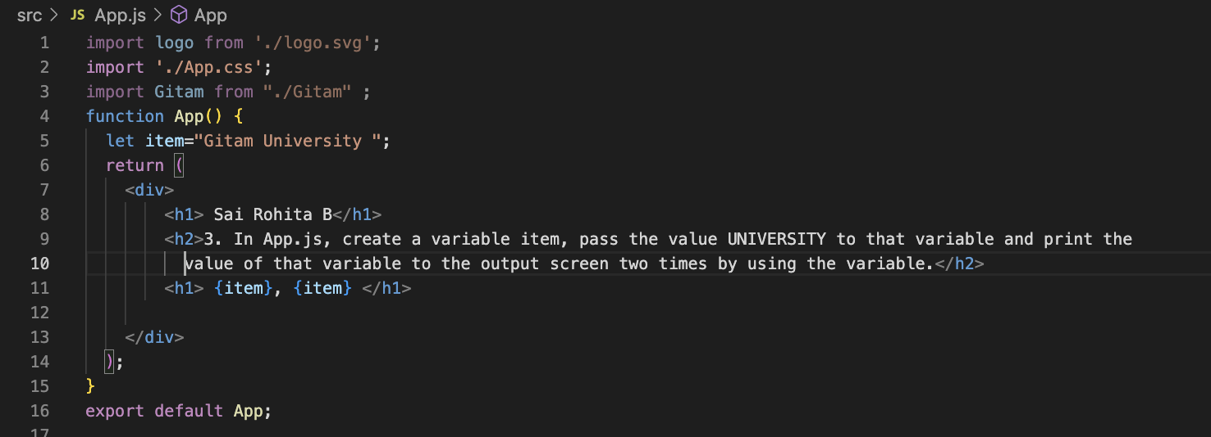

**Index.js**



**Output :**

